REPORT ON ‘CRIMINOLOGY AND FORENSIC SCIENCE’, GUEST LECTURE 2023

NAME OF THE PROGRAMME: | ‘CRIMINOLOGY AND FORENSIC SCIENCE’, For LLB IVth SEM(5years), LLB VIIIth SEM(5years) and IVth SEM (3 Years)
DATE AND DAY: | 6th April 2023.
TIME: | 012:00 P.M- 1.30 PM

On 6th Aril 2023, an Offline guest lecture was conducted by Dr. Ambedkar College, Department of Law, Deekshabhoomi, Nagpur for the students of LLB IVth SEM(5years), VIIIth Sem (5 yrs) and IVth SEM Semester (3 yrs course). Total 56 students attended the program. The Program was conducted under the guidance of Prof. Dr. H.V.Menon Head of the Department of Law and Dr. Sandhya Kalamdhad, , in seminar room at 012.00 P.M.

Course content delivered in the webinar is as follows
The speaker of the session Adv.Shubham Sahu presented the keynote address on Criminology and Forensic Science’ with a practical aspect.
This lecture was arranged with the motive of sharing the knowledge and practical experience of Adv.Shubham Sahu who is an expert in his field. Adv. Shubham Sahu started lecture by telling the student how forensic science is a broad field including multitude practices like DNA and RSS, fingerprint analysis, blood stain pattern, analysis etc. He emphatical put how Forensic Science is a part of the law that aids in evaluating many features such as DNA, fingerprints, blood samples, chemical and toxin tests, and so on in a trial and investigation of a case. He also explained how Forensic evidence can also utilised to connect crimes that are suspected and how it is related with DNA evidence, for example, forensic science discusses the uniqueness of the perpetrator of the crime. He talk about how Forensic evidence also aids in linking crimes, assist law enforcement officials in narrowing the spectrum of probable suspects, and establish patterns of crime that may be utilised to identify and prosecute individuals.
He discussed different aspect and application of science to criminal and civil laws mainly on the criminal side during criminal investigation as governed by legal standards of admissible evidences and criminal procedures. Provision like section 67, 73, 53, 54 to 93 of CrPC with practical example and how forensic studies can be used while applying these sections was the most talked about topic there by emphasizing on how forensic science is a critical element of criminal justice system. He also discussed what is FSLS-32, CFSL-7, GEOD-2, NFSU-9. Focusing on how forensic science different test study evidences from Crime Scene and elsewhere and also how to protect the evidence in the examination process and such other details. At the end question answer session was held which were satisfactorily answered by the guest speaker.

Adv. Shubham Sahu Interacting with students

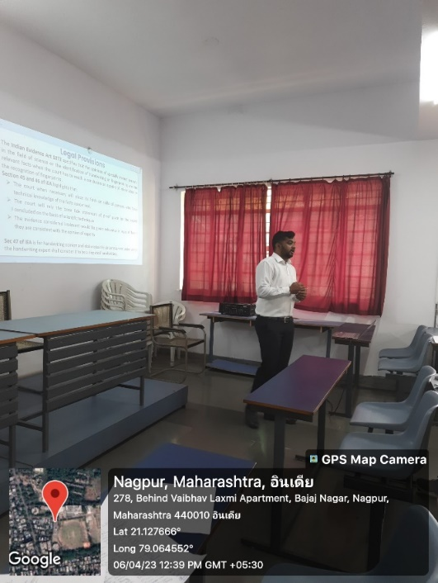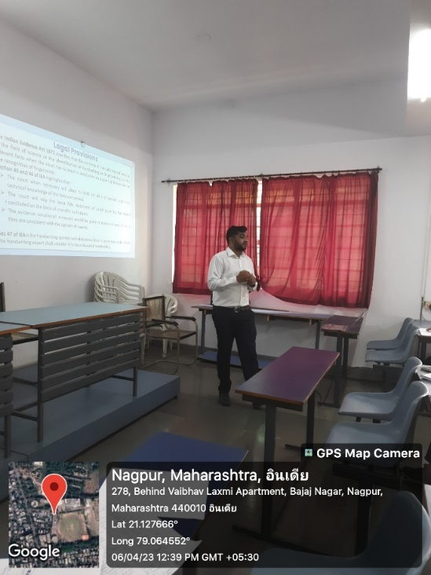

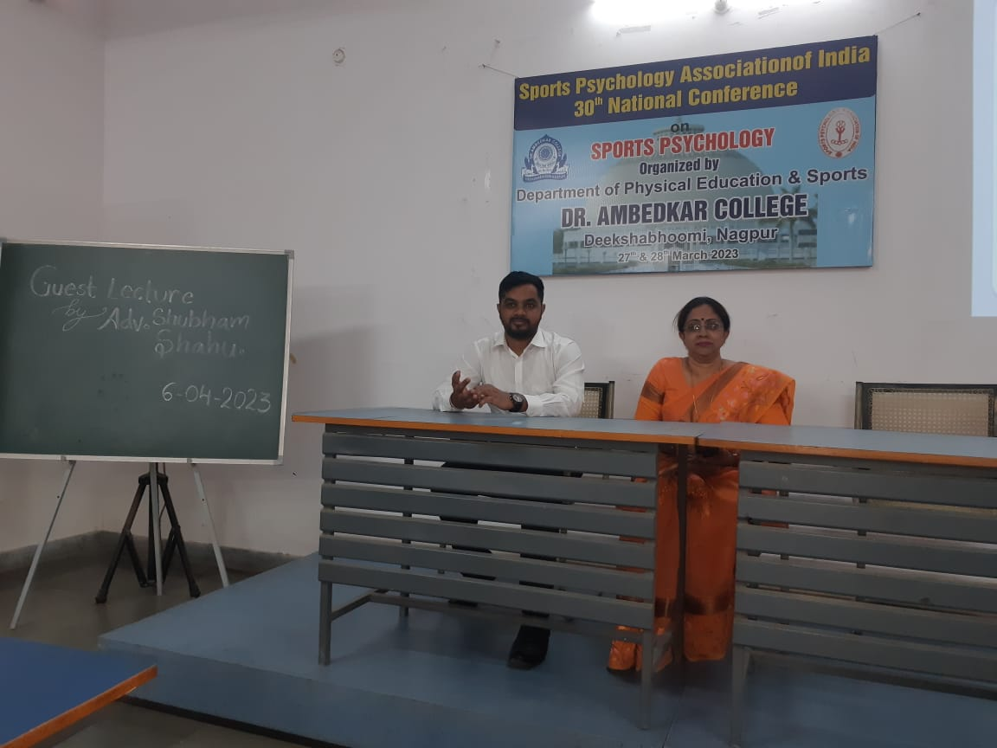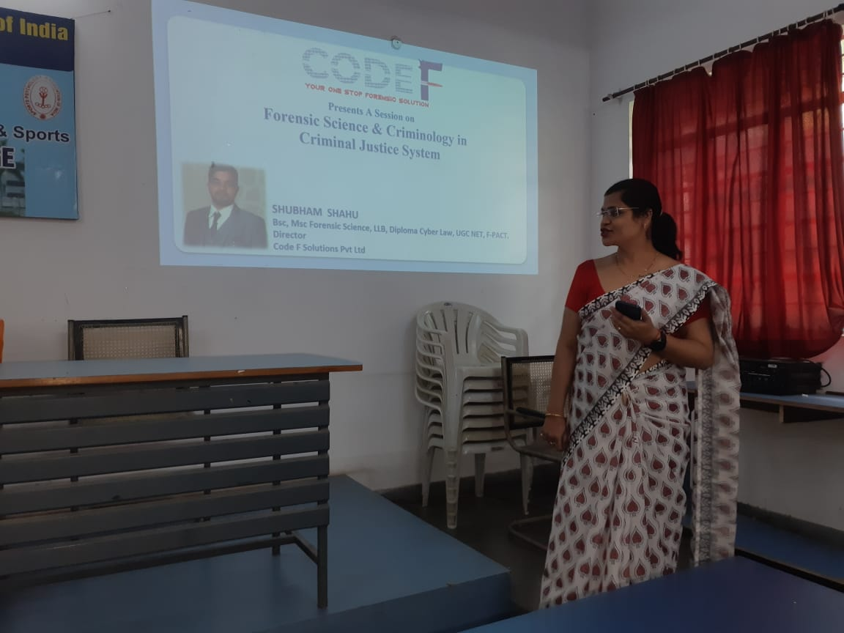

Feedback form

